Rest of the manuscript work

Method: PRISMA

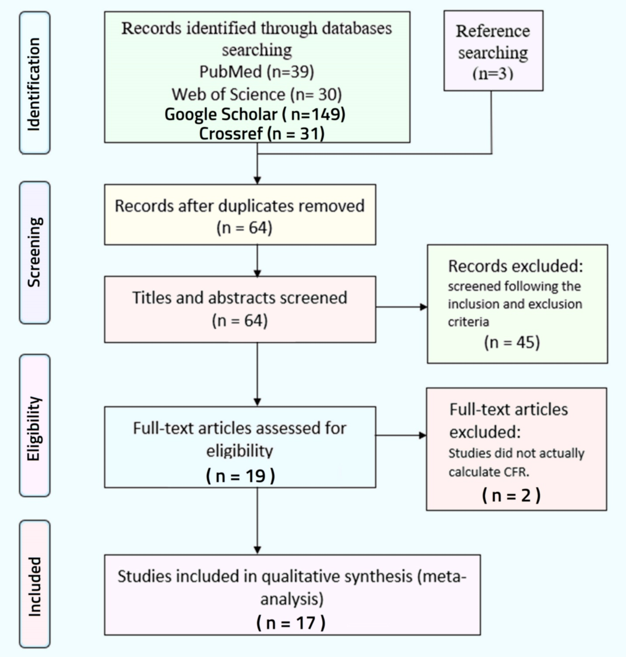

|  |  |  |  |  |  |  |
| --- | --- | --- | --- | --- | --- | --- |
| Ref. | Country  Region  Continent | Antibiotic-resistant | Bacteria | Sample | Size | Pattern of resistant |
|  |  |  |  |  |  |  |
|  |  |  |  |  |  |  |
|  |  |  |  |  |  |  |
|  |  |  |  |  |  |  |
|  |  |  |  |  |  |  |
|  |  |  |  |  |  |  |
|  |  |  |  |  |  |  |

Forest plot and Funnel plot

Result